Contenido

OOP principles 2

∙ Abstraction: 2

∙ Encapsulation: 3

∙ Inheritance 4

∙ Polymorphism 5

override 5

overload 5

Value type VS Reference type 5

Cycle management 10

Generic types 11

Collections 11

Generic Collections: 11

∙ List (List<T>): 11

∙ Dictionary (Dictionary<TKey, TValue>): 12

∙ SortedList/Set (SortedList<Tkey,TValue>/Set<T>): 12

∙ Stack (Stack<T>): 13

∙ Queue (Queue<T>): 13

∙ HashSet (HashSet<T>): 14

∙ LinkedList (LinkedList<T>): 14

Non-Generic Collections: 14

∙ Array (T[]): 14

∙ Hashtable: 14

∙ The ArrayList: 14

**Difference between a list and an array** 16

Readonly vs Constant 16

Abstract Class vs Interface 16

**When to use Interface and when Abstract class?** 17

Static Class 17

Extension methods 18

LINQ 19

Lamdas 20

Func and Action delegates 21

Exception handling 21

Handled and unhandled exceptions (checked and unchecked) 22

API basics 22

Httpclient 23

# OOP principles

* Abstraction:

First you have to know what an **object** is, an **object** is a thing in the real world about which you can store and process information (Another name for an object is **entity**)

**Abstraction** **helps us to simplify reality**, for example, of a person class that could abstract many things (gender, clothing, hair, skin color, age, date of birth, occupation, first name, middle name, last name, favorite movie, etc..), but we only get the information that interests us (first name, age)

A **class is a template** to create objects

An **object is an instance of a class**

In an **object we can define the properties values**, to make each object unique

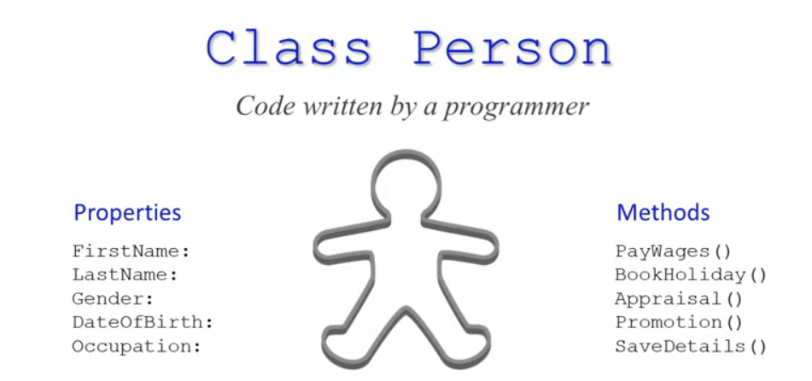

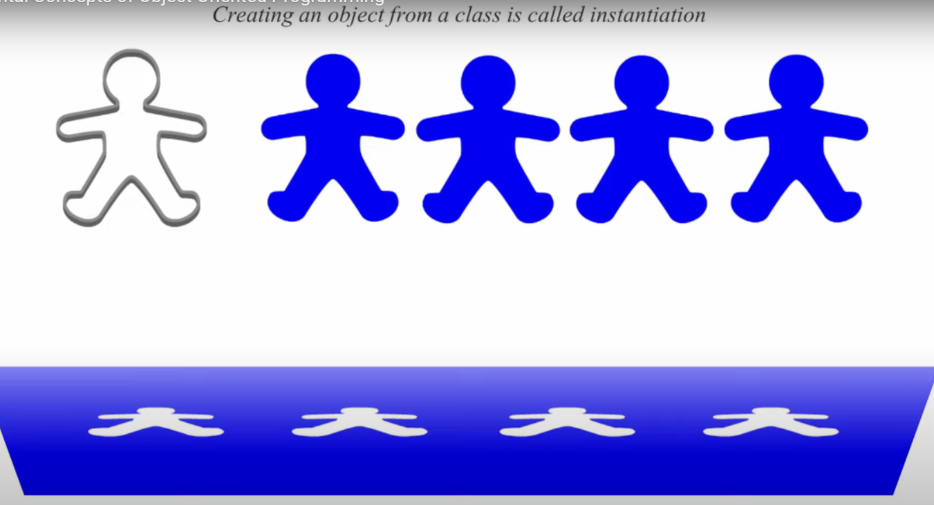

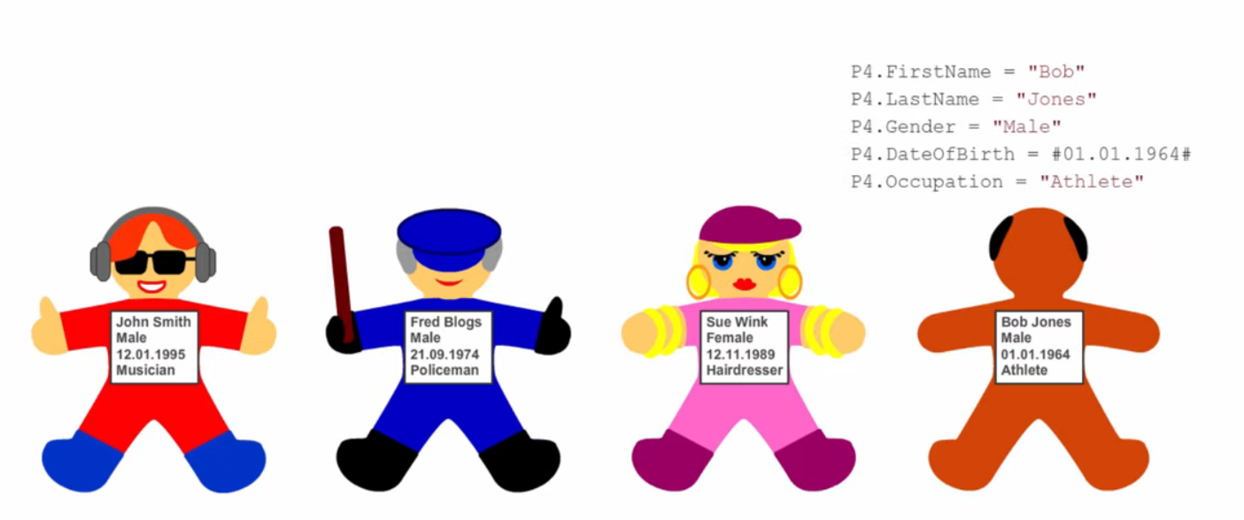

* Encapsulation:

**Hide data and complexity** for the programs and programmers that make use of it

**Private**: it is only accessible within that same class

**Public**: is accessible from any part of the code

**Protected**: it is accessible within the same class and by any class derived (inherited) from it

**Internal**: It is accessible only within the same assembly. A C# assembly can be a DLL file or an executable (EXE).

* Inheritance

This means that a class can derive its methods and properties from another class

Base-class: class at the start of the inheritance hierarchy

Sub-class: any class that derives from another class

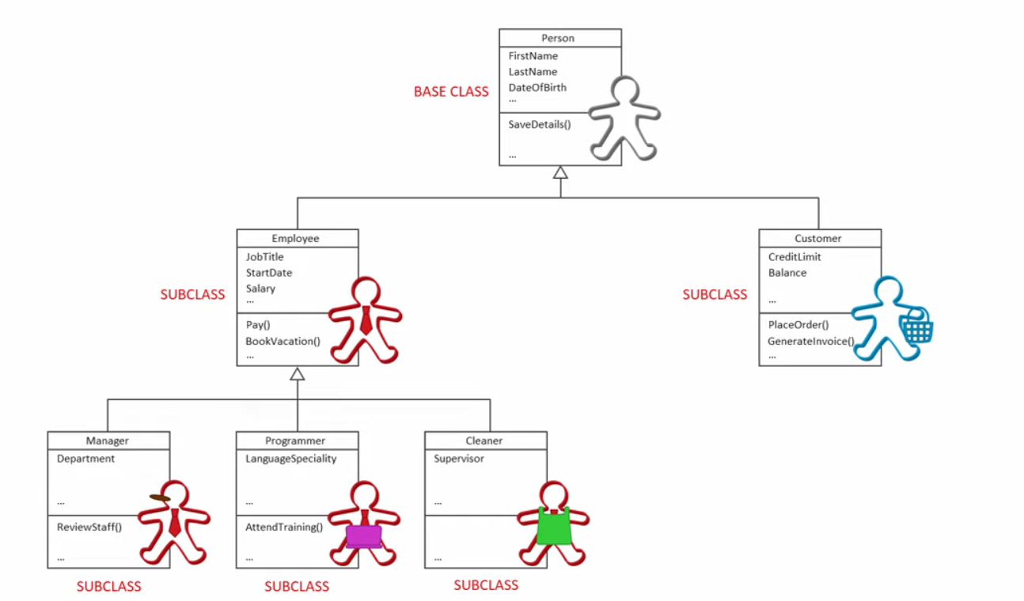

Superclass: any class that is derived from

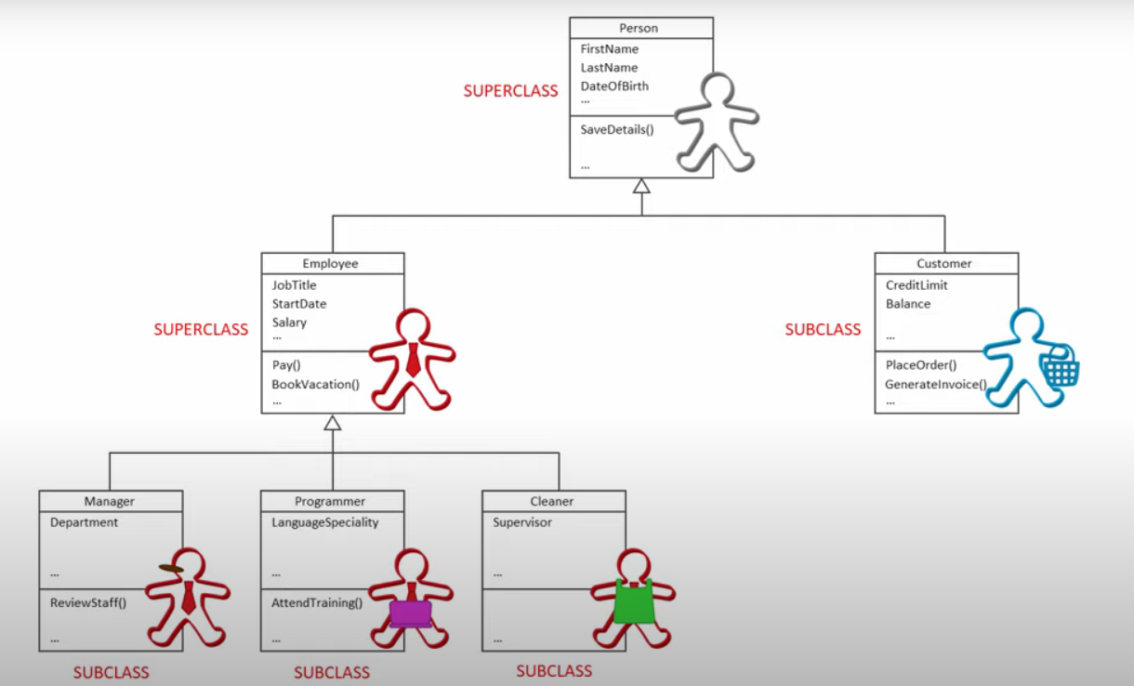

* Polymorphism

### override

* A class can implement an inherited method in its own way
* is used to override a method in a derived class
  + Virtual Method: Methods that use the virtual keyword are used to define methods that can be overridden in derived classes

### overload

* is used to define multiple methods with the same name but different parameters within the same class.

The **signature** of a method in C# is a unique combination of its name and the types of its parameters

# Value type VS Reference type

* Value type
  + Directly contain values
  + Is immutable data which contains the data.
  + It is stored in memory area **Stack**

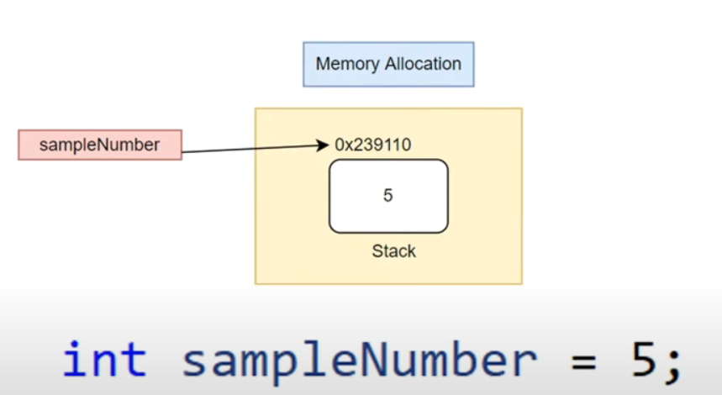

All value types

* Bool
* Enum
* Short
* Byte
* Float
* Struct
* Char
* Int
* Uint
* Decimal
* Long
* Ulong
* Double
* Sbyte
* Ushor
* Reference type
  + Holds a memory address of location where value is store
  + Data is stored in **Heap** with pointer from stack

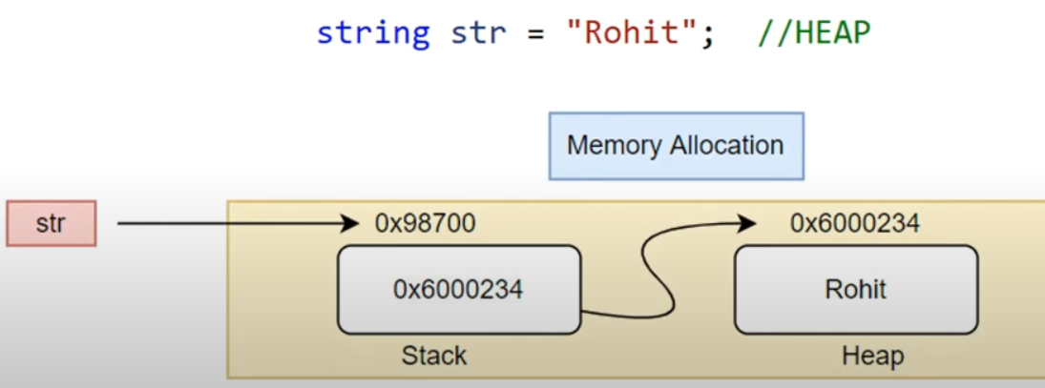

All reference types

* String
* Array
* Class
* Delegate
* Collections (List,dictionary,HashSett,etc)

Example 1:

Once it is part of an object instance they will be stored in heap

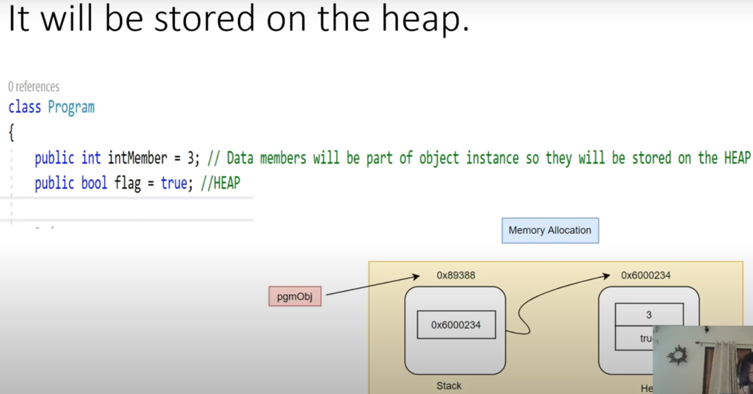

Example 2

Once declared inside a method it takes the normal course, that is stored in stack

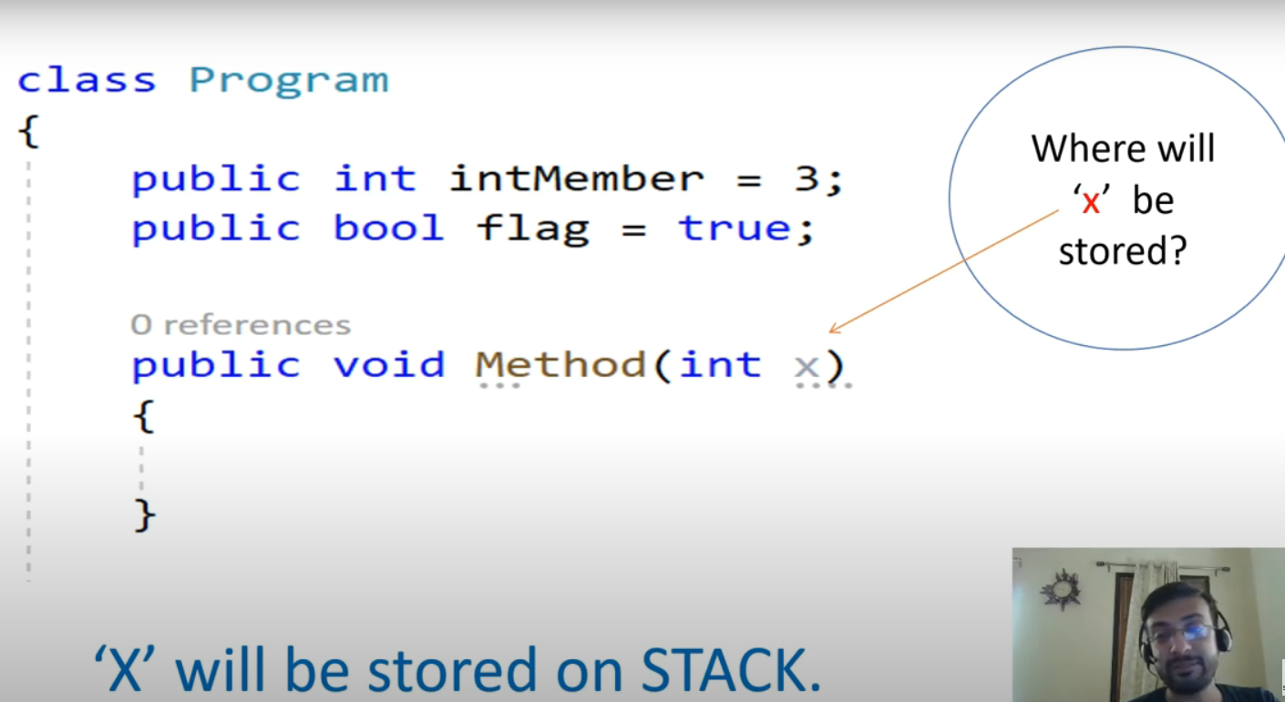

Example 3

Doesn’t matter the type of the array, an array is always stored in heap

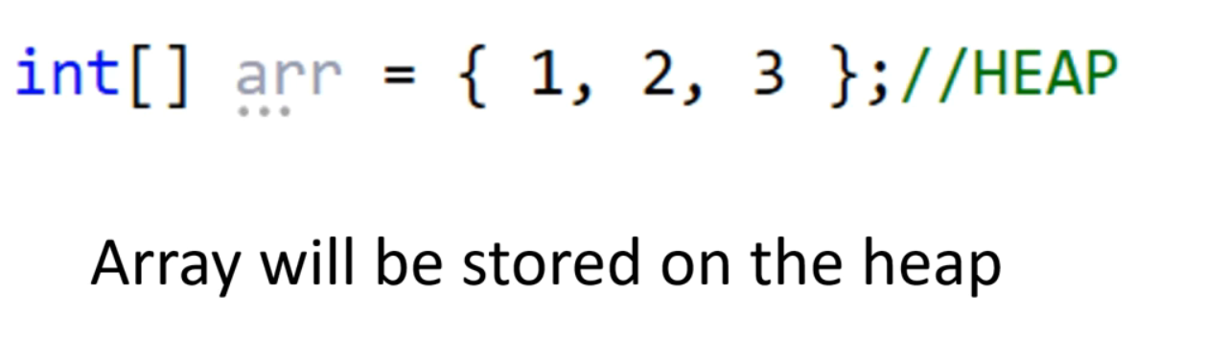

Example 4

Value type doesn’t change the value

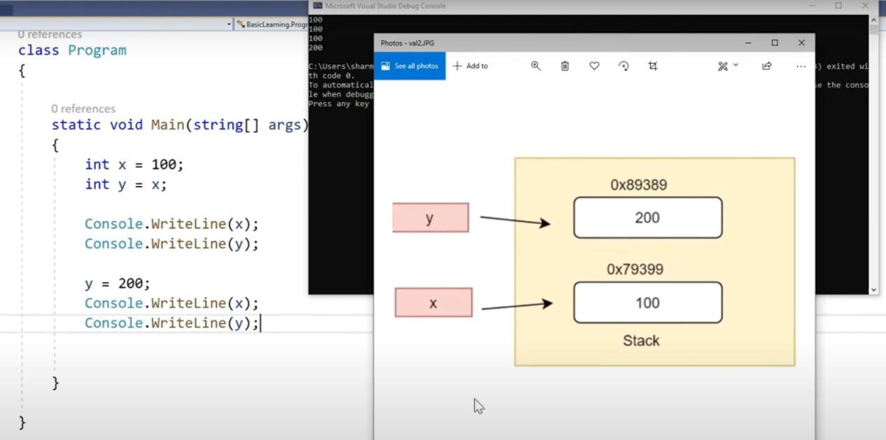

Example 5

Reference type changes the value

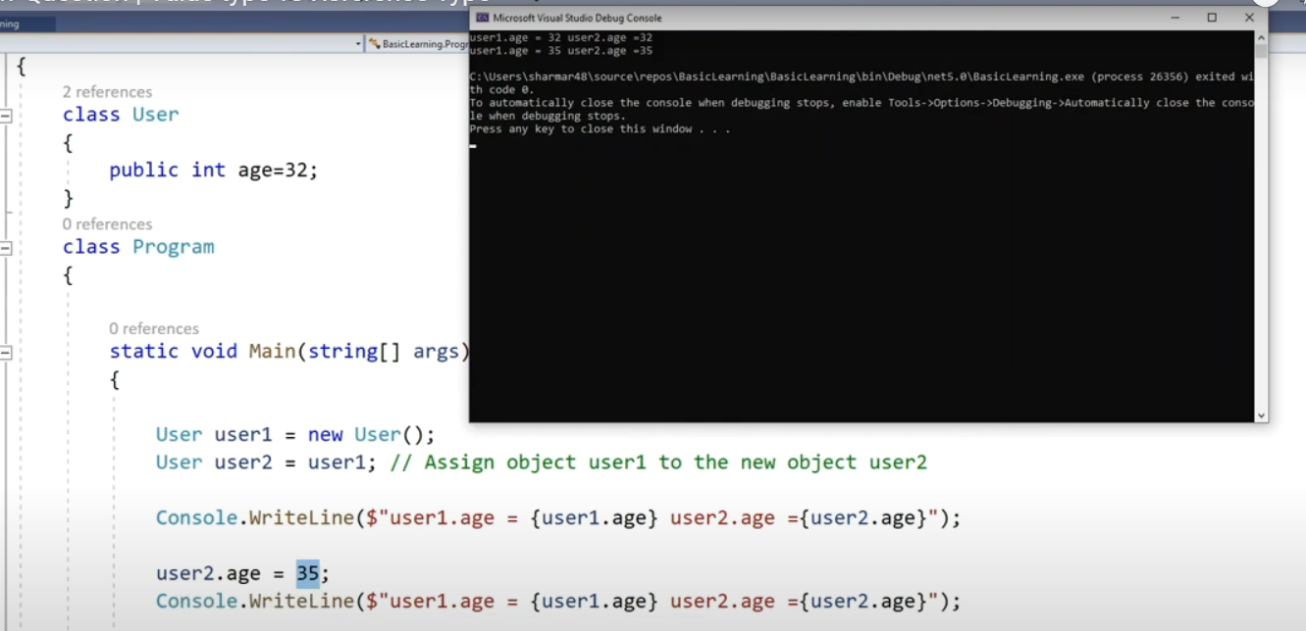

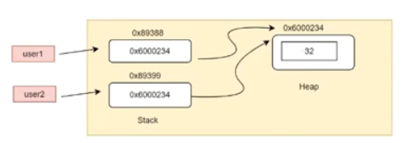

**Note**: if you modify the value of user 1, user 2 value is also modified

# Cycle management

**.NET is a software development platform** that provides a runtime environment and libraries for creating applications, while **C# is a programming language** used to write application code on the .NET platform.

* **Software testing life cycle (STLC)**
  + Requirements analysis
  + Test planning
  + Test case design and development
  + Test environment setup
  + Test execution
  + Test reporting
  + Test closure
* **Waterfall model (SDLC)**
  + Takes too long to deliver
  + The testing is too late costing a lot

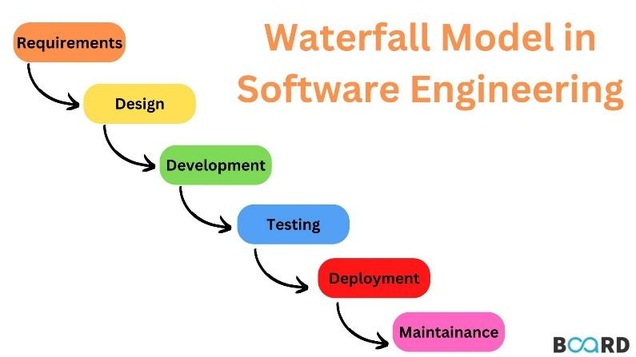

* **V-model**
  + Still takes too long

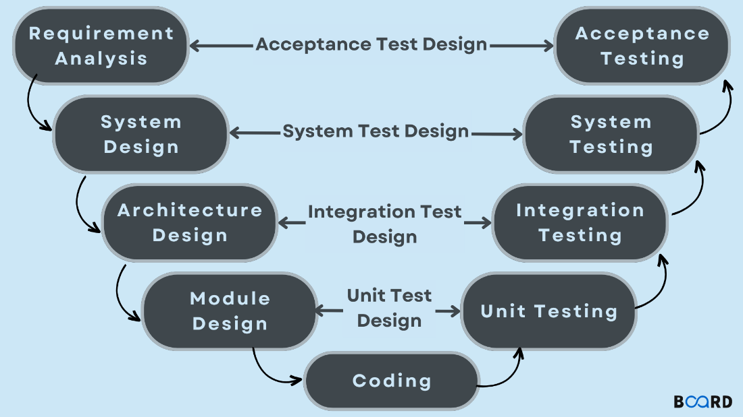

* Iterative development model
  + Is not Scrum, Scrum is agile
  + Both Scrum and the iterative development model are effective approaches to software development that emphasize incremental delivery, customer feedback, and adaptability. However, **Scrum is a complete agile framework with specific roles and practices,** while **the iterative model is a more generic approach** that can be tailored based on the specific needs of the project.

# Generic types

In C#, <T> is a placeholder used in generic types and methods. **It represents** **a type parameter that can be replaced by any actual data** type when the generic type or method is instantiated or called. This allows you to create reusable code that works with different data types without having to rewrite the code for each specific type.

# Collections

In C#, collections are used to store and manipulate groups of related objects. There are several built-in collection types available in the .NET Framework, each with its own characteristics and use cases. Here are some of the commonly used collections in C#:

## Generic Collections:

* List (List<T>):
  + Lists are dynamic collections that can grow or shrink in size dynamically.
  + They provide methods for adding, removing, and accessing elements.
  + Example: List<string> names = new List<string>();

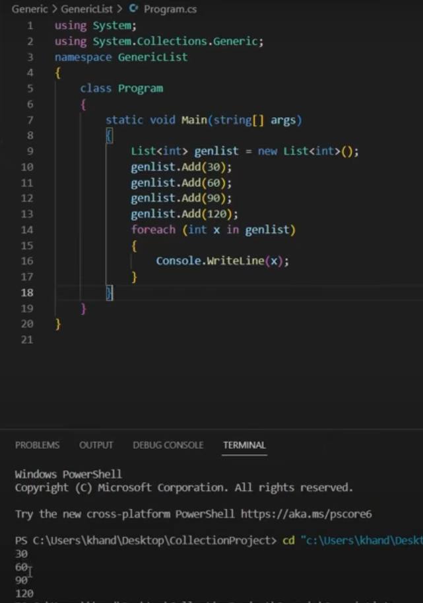

* Dictionary (Dictionary<TKey, TValue>):
  + Dictionaries store key-value pairs where each key is associated with a unique value.
  + They offer fast lookup and retrieval of values by key.
  + Example: Dictionary<string, int> ages = new Dictionary<string, int>();

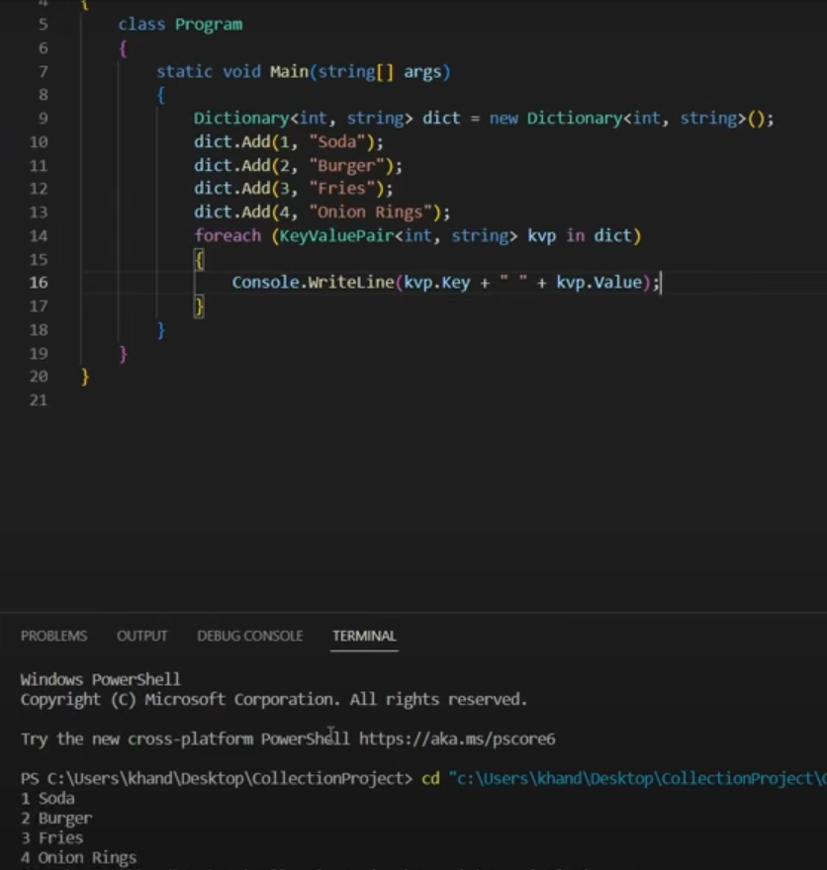

* SortedList/Set (SortedList<Tkey,TValue>/Set<T>):
  + SortedList/Set store unique elements in sorted order.
  + They automatically sort elements as they are added to the collection.
  + Example: SortedList<int,string> sortedList = new SortedList<int,string>();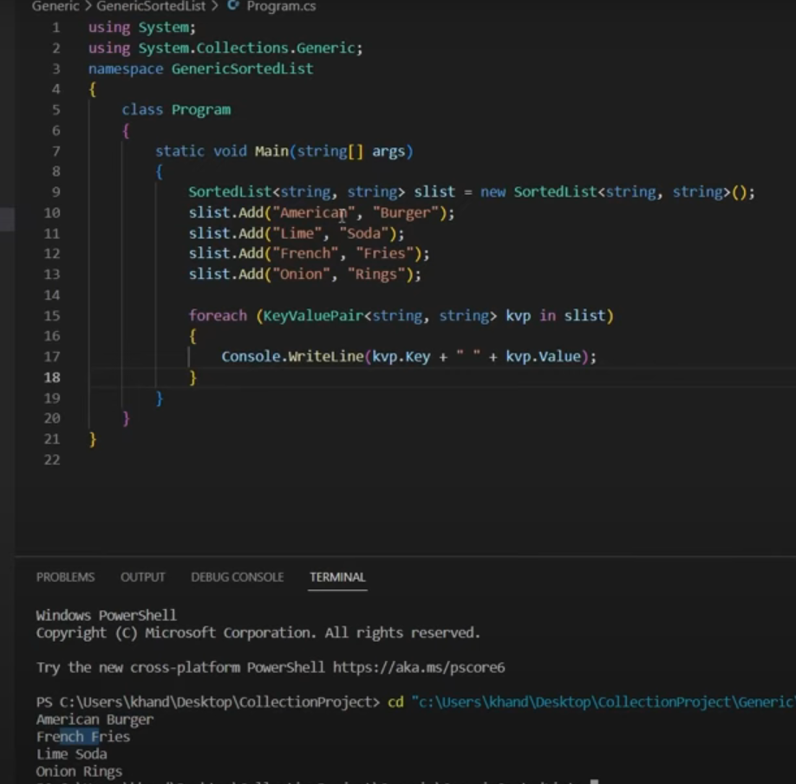
  + SortedSet<int> sortedNumbers = new SortedSet<int>();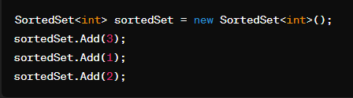
* Stack (Stack<T>):
  + Stacks implement a last-in-first-out (LIFO) data structure, where elements are added and removed from the same end.
  + Example: Stack<int> stack = new Stack<int>();

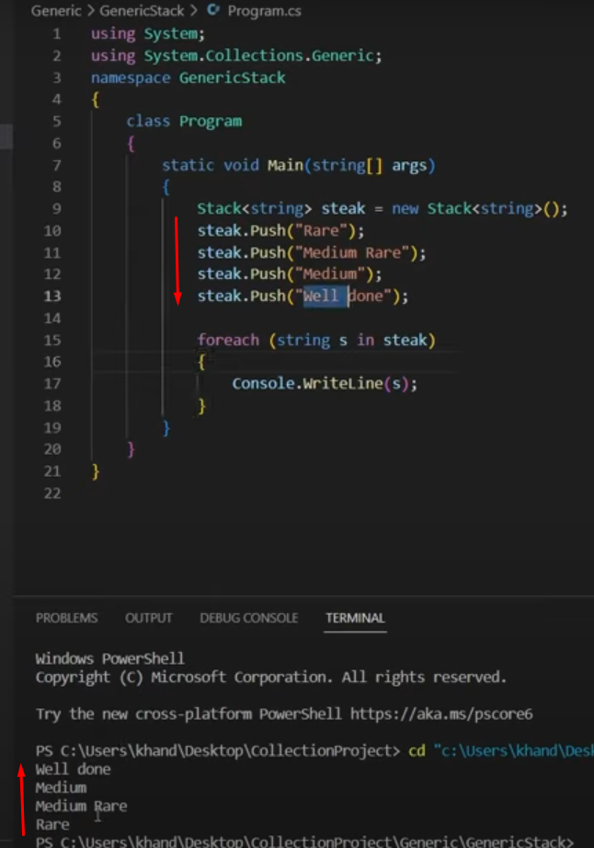

* Queue (Queue<T>):
  + Queues implement a first-in-first-out (FIFO) data structure, where elements are added to the end and removed from the beginning.
  + Example: Queue<string> queue = new Queue<string>();

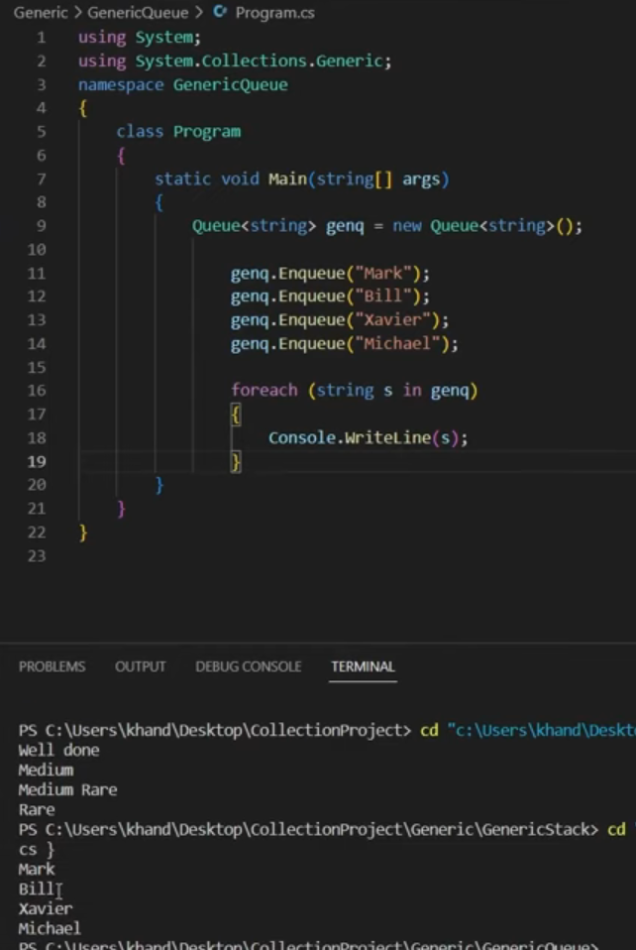

* HashSet (HashSet<T>):
  + HashSets store unique elements and provide fast lookup operations.
  + They do not allow duplicate elements.
  + Example: HashSet<int> uniqueNumbers = new HashSet<int>();

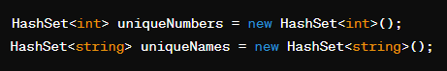

* LinkedList (LinkedList<T>):
  + LinkedLists are collections of nodes, where each node contains a value and a reference to the next or previous node.
  + They allow efficient insertion and removal of elements at any position in the collection.
  + Example: LinkedList<int> linkedList = new LinkedList<int>();

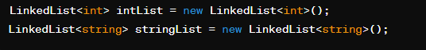

## Non-Generic Collections:

* Array (T[]):
  + Arrays are fixed-size collections that store elements of a specific type.
  + They offer fast access to elements by index but cannot be resized once created.
  + Example: int[] numbers = new int[5];



* Hashtable:
  + It allows you to store and retrieve values based on a key.
  + Keys must be unique within the Hashtable, but values can be duplicated.
  + Elements are not stored in any particular order.
  + Example: HashTable uniqueNumbers = new HashTable();

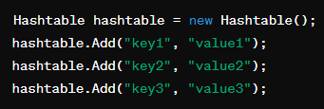

* ArrayList:
  + it's part of the older .NET Framework collections and is not recommended for new development
  + Is a non-generic collection that can store elements of any data type, and it dynamically resizes as needed to accommodate the number of elements added to it.
    - non-generic collection: this means it can store objects of any type, and you'll need to cast elements to the appropriate type when retrieving them from the ArrayList.
  + Example: ArrayList list = new ArrayList();

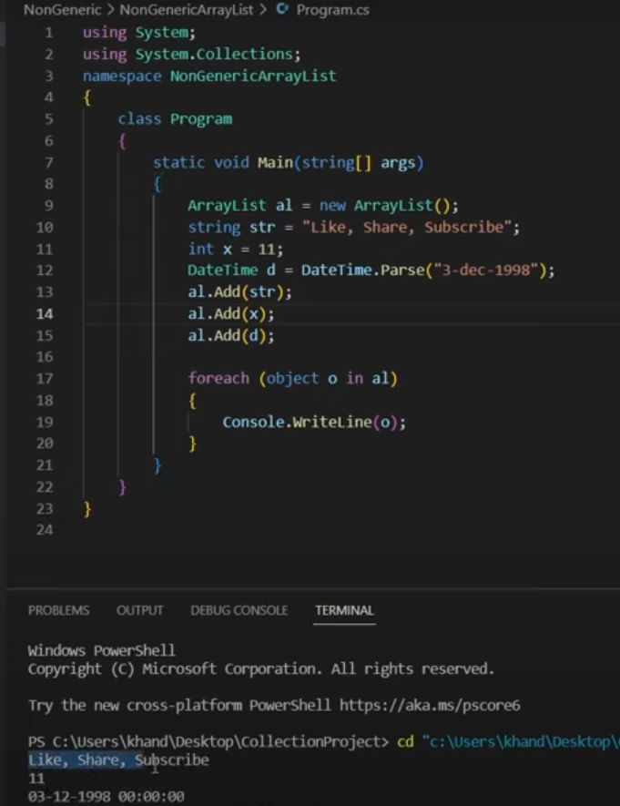

* Queue
* Stack
* SortedList

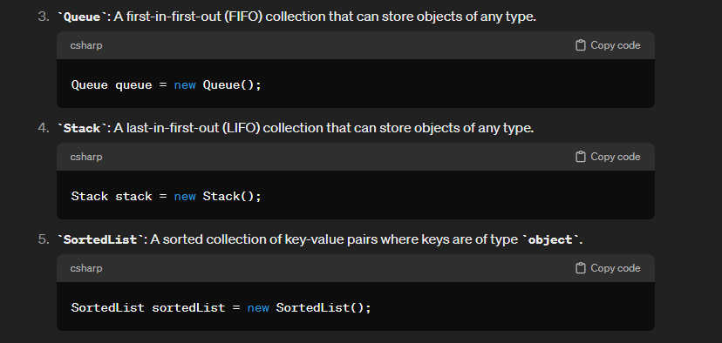

# Difference between a list and an array

Arrays have a fixed size and are more efficient for random access, while lists are dynamic and offer more flexibility for adding and removing elements. The choice between them depends on the specific requirements and constraints of your application.

# Readonly vs Constant

* Constant field value cannot be changed, but Readonly field value can be changed
* **Constant is a COMPILE** time constant **and Readonly is a RUNTIME** constant
  + **const** for values that are known at compile time and will never change, and use **Readonly** for values that need to be determined at runtime
* Using constant, we must assign values with declaration itself. Readonly fields can be assigned in declaration as well as in the constructor part

Example 1

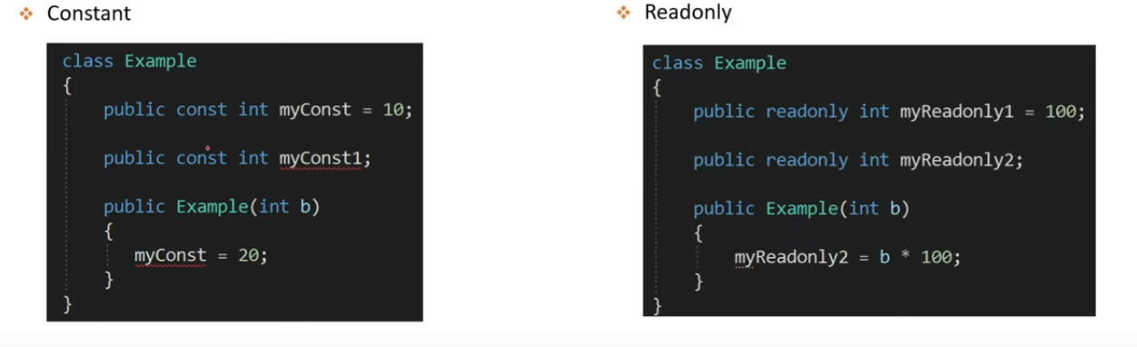

# Abstract Class vs Interface

* Abstract class contains both declaration and definition methods
* Interface should contain only declaration of methods
  + With C# 8.0 you can now have default implementations/definition of methods in an interface. But that is recommended only if you are creating from scratch

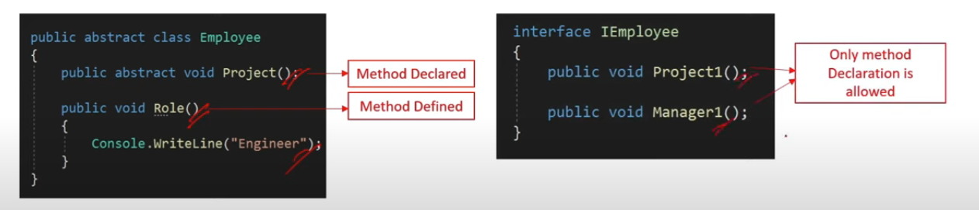

* Abstract class does no support multiple inheritance, the interface does

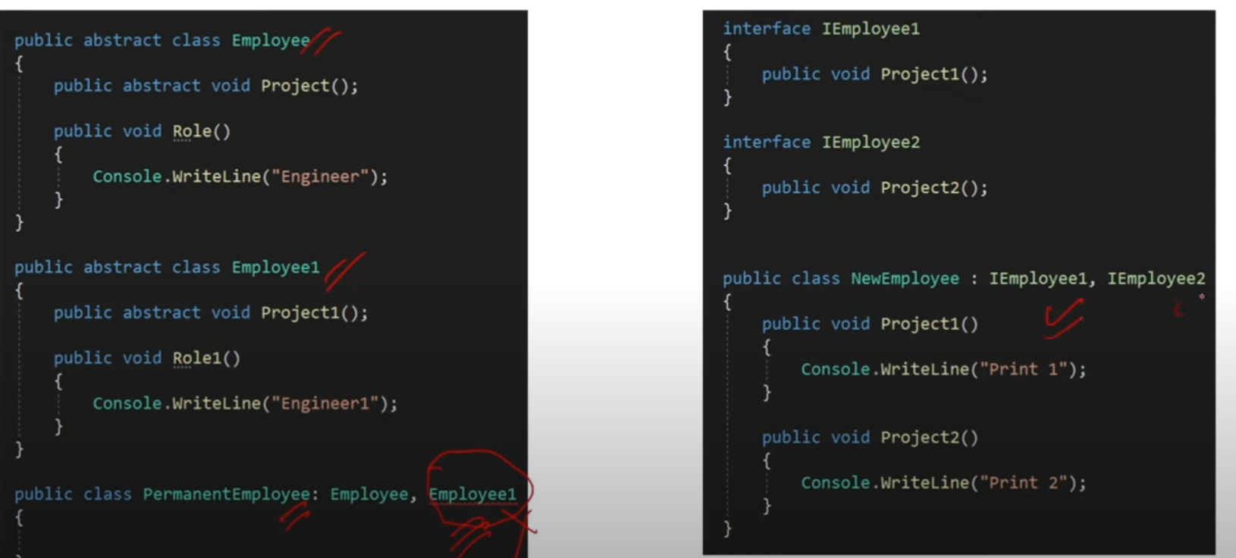

* Abstract class can have constructors, interface don’t

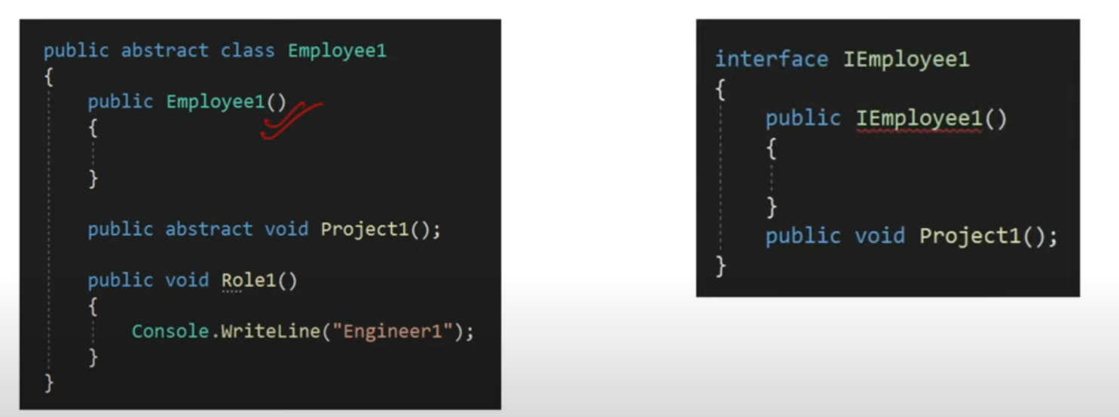

## **When to use Interface and when Abstract class?**

* An **interface** is a good choice when you know a **method** has to be there, but it can be **implemented** **differently by independent derived classes**
* **Abstract** class is a good choice when you are sure some **methods** are concrete/defined and must be **implemented** in the **same way in all derived classes**
* Interfaces are more used due the flexibility to modify the behavior at later stage

# Static Class

* Can not be created (instantiated as an object)
* Can not be inherited
* Is used as containers for static members like methods, constructors and properties
* It is primarily used to group related utility methods or constants together, and it does not require you to create an instance of the class to access its members.
  + Static members of a static class are shared across all instances of the application

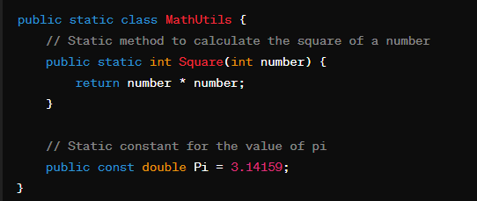

# Extension methods

* Adds methods to a complied class without modifying the original class

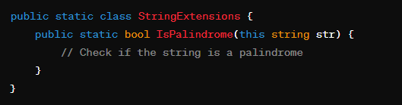

Example 2

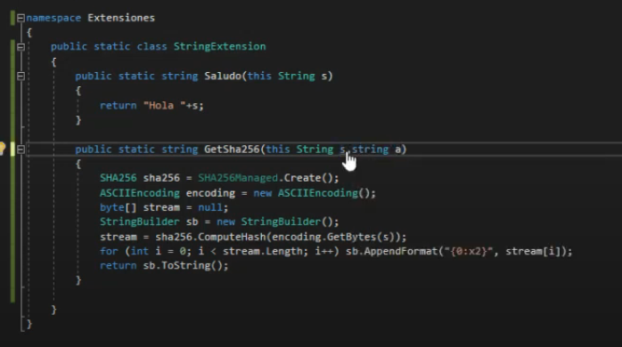

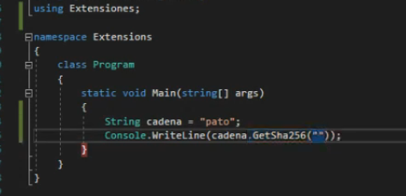

# LINQ

LINQ (Language Integrated Query) is a set of features in C# that provides a uniform way of querying data from different sources such as collections, arrays, databases, XML, and more. LINQ allows developers to write queries directly within C# code using a SQL-like syntax, making it easier to query and manipulate data.

Here are some key aspects of LINQ:

* Query Syntax and Method Syntax:
  + LINQ supports two main syntaxes: query syntax and method syntax.
  + Query syntax uses SQL-like keywords such as from, where, select, group by, order by, etc.
  + Method syntax uses extension methods provided by LINQ operators such as Where, Select, OrderBy, GroupBy, etc.
* LINQ Providers:
  + LINQ is extensible and supports various LINQ providers for different data sources.
  + LINQ to Objects: Querying in-memory collections such as arrays, lists, and dictionaries.
  + LINQ to SQL: Querying relational databases using LINQ.
  + LINQ to XML: Querying and manipulating XML data.
  + LINQ to Entities: Querying entity data models in Entity Framework.
* Deferred Execution:
  + LINQ queries use deferred execution, meaning that the query is not executed immediately when it's defined but is executed when the query results are enumerated.
  + Deferred execution allows for more efficient query execution and optimization.
* Integration with C# Language:
  + LINQ is integrated into the C# language itself, allowing for seamless integration of queries with other C# code.
  + LINQ queries can be used with other language features such as lambda expressions, anonymous types, and object initializers.
* Type Safety:
  + LINQ provides type safety at compile time, ensuring that queries are valid and compatible with the data sources.

Here's a simple example of LINQ query using method syntax:

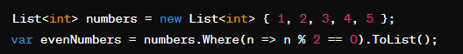

And here's the same query using query syntax:

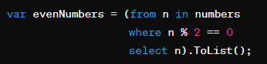

# Lambdas

A lambda expression in C# is a concise **way to represent an anonymous function or a delegate using the =>** syntax. Lambda expressions are commonly used in LINQ queries, event handling, and functional programming constructs to define inline functions without explicitly declaring a separate method.

Here are some key aspects of lambda expressions:

* Concise Syntax:
  + Lambda expressions provide a concise syntax for defining anonymous functions, reducing the need for boilerplate code.
* Delegate Types:
  + Lambda expressions are often used to create instances of delegate types, allowing for the creation of inline functions that can be passed as arguments to methods.
* Capturing Variables:
  + Lambda expressions can capture variables from the enclosing scope, allowing them to be used within the expression.
* Return Value:
  + If the lambda expression consists of a single expression, the return value is implicitly determined by the type of the expression.
  + If the lambda expression consists of multiple statements, the return value must be explicitly specified using the return keyword.
* Parameter Types:
  + Parameter types can be explicitly specified or inferred by the compiler based on the context.
* Here are a few examples of lambda expressions:

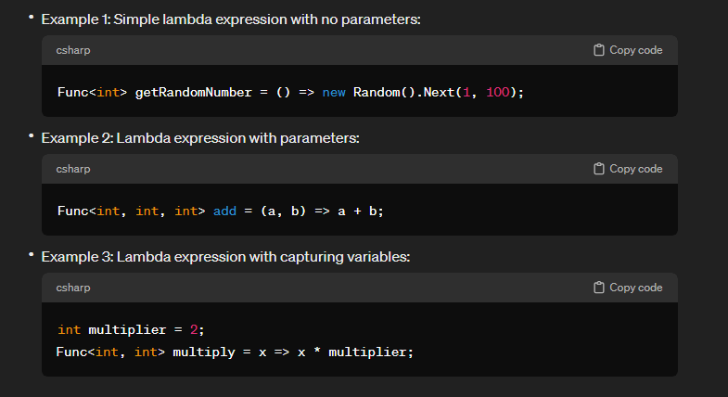

# Func and Action delegates

The main difference between Func and Action lies in their return types. The Func delegate allows you to specify a return type, whereas the Action delegate does not return a value. Both delegates can have up to 16 parameters.

Example 1 Func

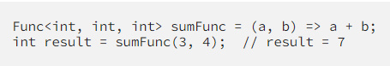

Explanation: In this example, we define a Func delegate that takes two integer parameters and returns an integer. We assign a lambda expression to the delegate, which calculates the sum of the two parameters and returns the result.

Example 2 Action

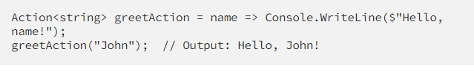

Explanation: In this example, we define an Action delegate that takes a string parameter. We assign a lambda expression to the delegate, which writes a greeting message to the console.

# Exception handling

* Use try-catch-finally
* Use Specific Exceptions: Instead of using the general `Exception` class, it’s better to catch more specific exceptions. This allows for more precise error handling and debugging.
* Avoid Catching Exceptions You Can’t Handle: If you can’t resolve an exception, it’s often better to let it propagate up the call stack to a level where it can be adequately addressed.
* Use `finally` Blocks for Cleanup: The `finally` block ensures that resources get released, regardless of whether an exception occurs.
* Don’t Rethrow Exceptions Incorrectly: Use `throw;` instead of `throw ex;` to preserve the original exception stack trace.
* Log Exceptions: Always log exceptions for future analysis. This can be invaluable for debugging and identifying recurring issues.

# Handled and unhandled exceptions (checked and unchecked)

* All classes which extend **RuntimeException** are called **unchecked**. They usually indicate programming bugs, such as logic errors or improper use of an API.
  + Example of unchecked exceptions:
    - ArithmeticException
    - NullPointerException
    - IndexOutOfBoundsException
    - IllegalArgumentException
    - ClassCastException
* Unchecked exceptions SHOULD NOT BE handled with try/catch - they should be treated as a bug and should be fixed (or avoided with if statements). Of Course you can use a try/catch block to handle a RuntimeException (for example NullPointerException), but it is NOT a good practice.
* Checked exceptions MUST BE either handled with try/catch blocks or when the method does not know how to handle them, they should be declared to be thrown by the method itself. Thus the responsibility for handling the exception is transferred to the methods that would invoke this very method.
* Unhandled (unchecked) exceptions are errors that not even allow the start of the application
* **Unchecked Exceptions**: Happen during runtime. Logic errors or misuse of the API. Errors also happen here. For example, when the application runs out of memory. Custom Exceptions also go here.
* **Checked Exceptions**: Happen during compilation time and the compiler usually tells you about these ones. These exceptions should be handled immediately.

# API basics

Http verbs (CRUD)

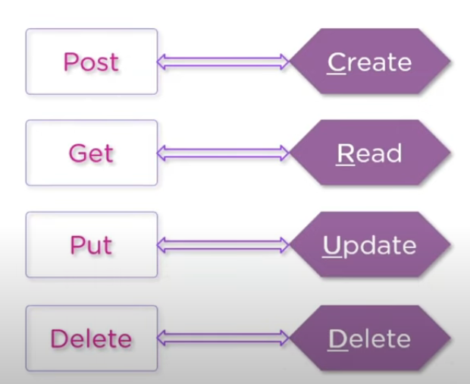

Http status codes

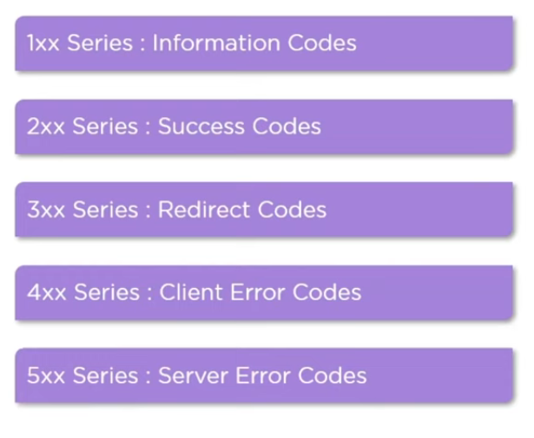

# Httpclient

* <https://www.youtube.com/watch?v=-t-5OZBGmVU&list=PL0kIvpOlieSPMzysCe2jTIxENapz6-Wnl&ab_channel=gavilanch2>
* Con la sentencia “using” se limpian los recursos del httpclient

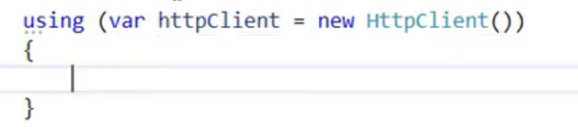

* Le pone la ruta del api, ejm

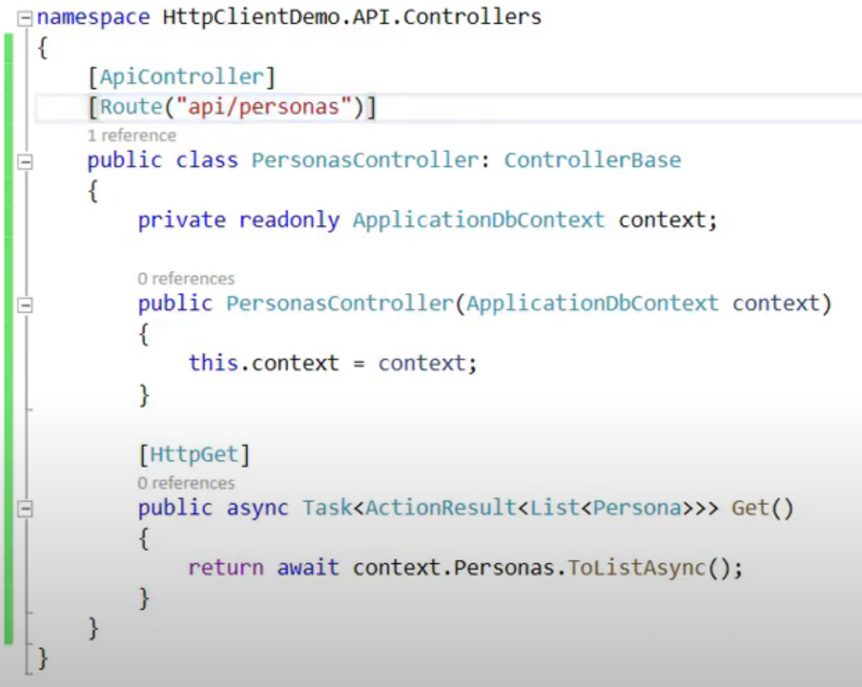

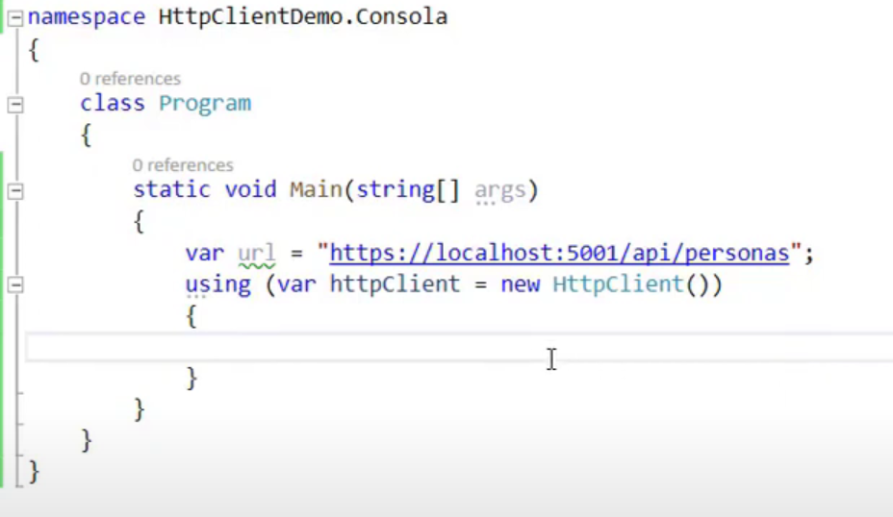

* Para obtener la respuesta de la api hay varias opciones, la que mas trae es “GetAsync”

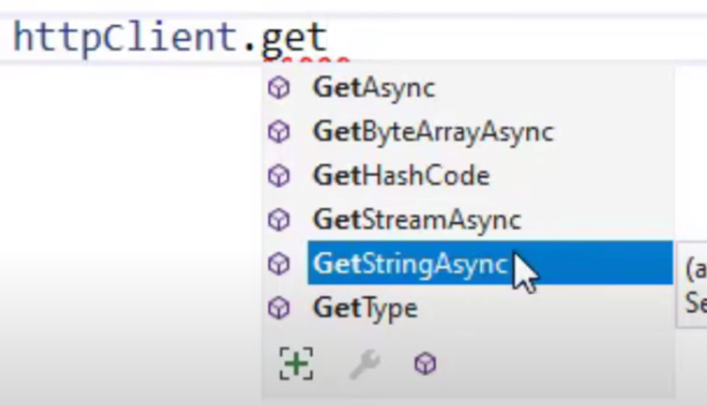

Como el método es asíncrono, se debe usar el “await” dentro de un método asíncrono “async”

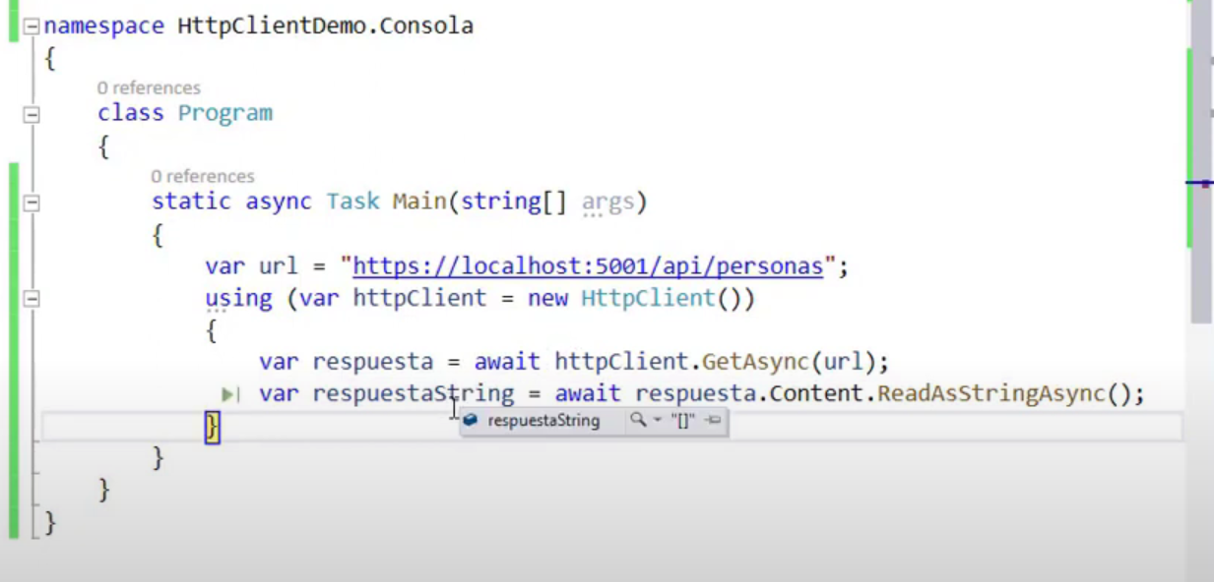

* Trajo la respuesta vacia porque la Db esta vacia, para ver datos en la respuesta el sig machetazo

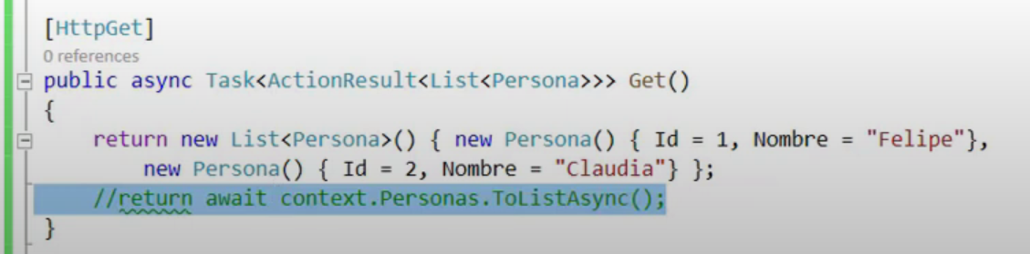

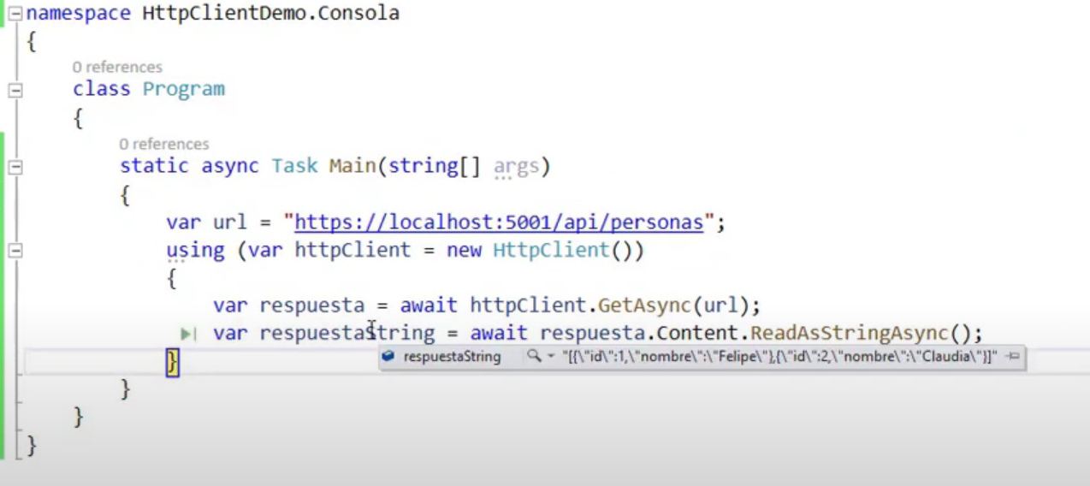

Des-serealizar es tomar un string (JSON - XML) y volverlo objeto, serializar es lo contrario

* Es importante que se fije en las mayúsculas y minúsculas del DTO o modelo del objeto, ya que, si no coinciden con las del body en string, falla la deserialización
* Con lo siguiente ignora las mayúsculas y minúsculas

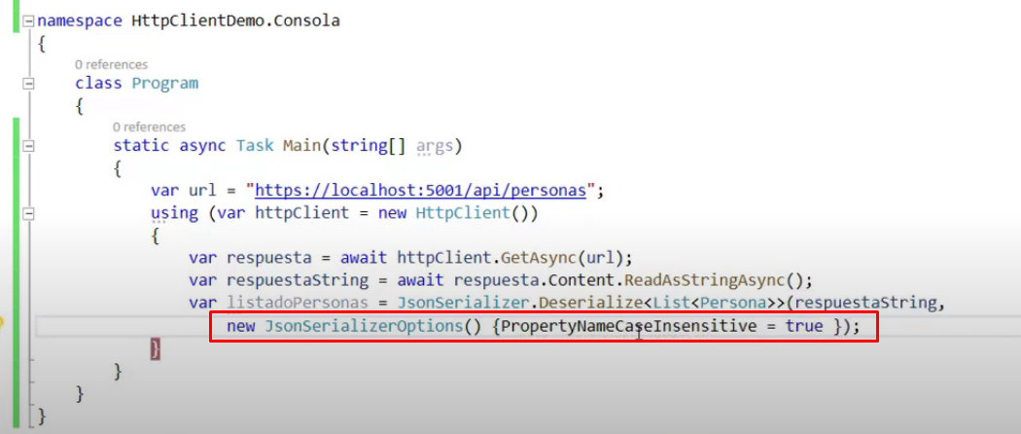

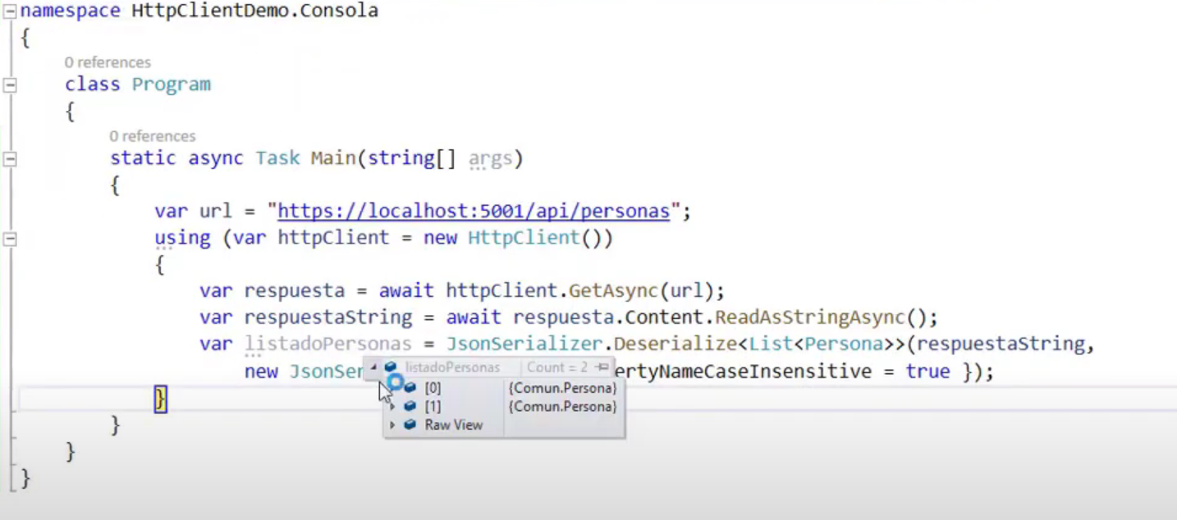

* Para el POST

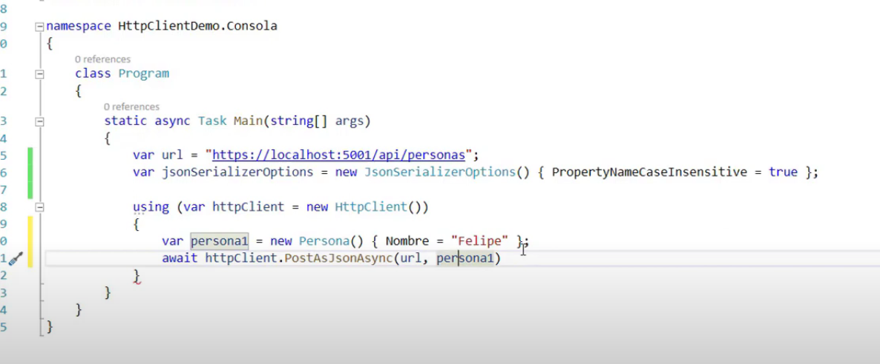

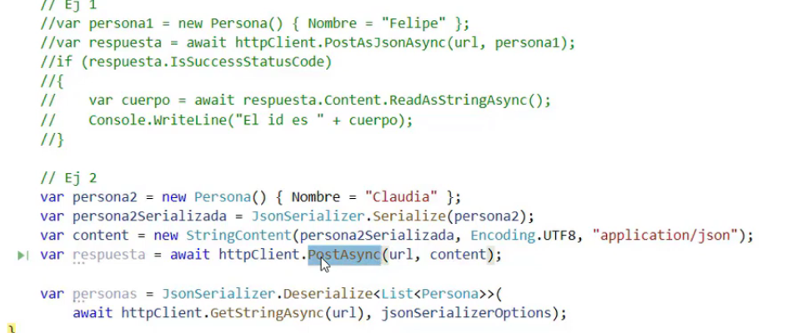

Tag “Required” para que se deba dar valor a una propiedad

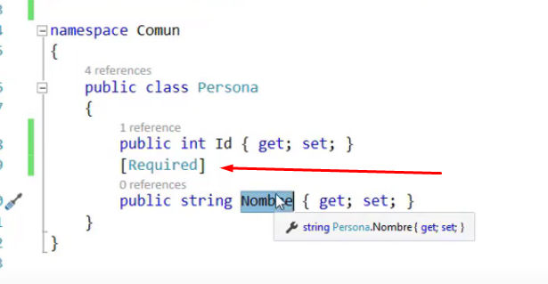

**Additional Information**

**Note**

In C#, you can define custom value types using the **struct** keyword. **These custom value types, also known as structs**, allow you to create data structures that behave like built-in value types such as int, float, etc. However, they also provide the flexibility to include both value types and reference types as fields.